AI Assistant Coding Assignment-2.5

Name: B.Palomi
HT.NO.: 2303A51233
Batch:19

Lab 2: Exploring Additional AI Coding Tools beyond Copilot – Gemini (Colab) and Cursor AI

Task 1: Refactoring Odd/Even Logic (List Version) Scenario
You are improving legacy code that calculates the sum of odd and even numbers in a list.

Prompt Used (Gemini / Cursor AI):
"Write a Python program to calculate the sum of odd and even numbers in a list, then refactor it to improve readability and efficiency."

Original Code (Legacy Version)
def calculate_odd_even_sums(numbers):
even_sum = 0
odd_sum = 0
for num in numbers:
if num % 2 == 0:
even_sum += num
else:
odd_sum += num
return even_sum, odd_sum
# Example usage:
my_list = [1, 2, 3, 4, 5, 6, 7, 8, 9, 10]
even_total, odd_total = calculate_odd_even_sums(my_list)

print(f"Original list: {my_list}")
print(f"Sum of even numbers: {even_total}")
print(f"Sum of odd numbers: {odd_total}")

Refactored Code (AI-Improved Version)

def calculate_odd_even_sums_refactored(numbers):
even_sum = sum(num for num in numbers if num % 2 == 0)
odd_sum = sum(num for num in numbers if num % 2 != 0)
return even_sum, odd_sum

# Example usage with refactored function:
my_list = [1, 2, 3, 4, 5, 6, 7, 8, 9, 10]
even_total_refactored, odd_total_refactored = calculate_odd_even_sums_refactored(my_list)

print(f"Original list: {my_list}")
print(f"Refactored - Sum of even numbers: {even_total_refactored}")
print(f"Refactored - Sum of odd numbers: {odd_total_refactored}")

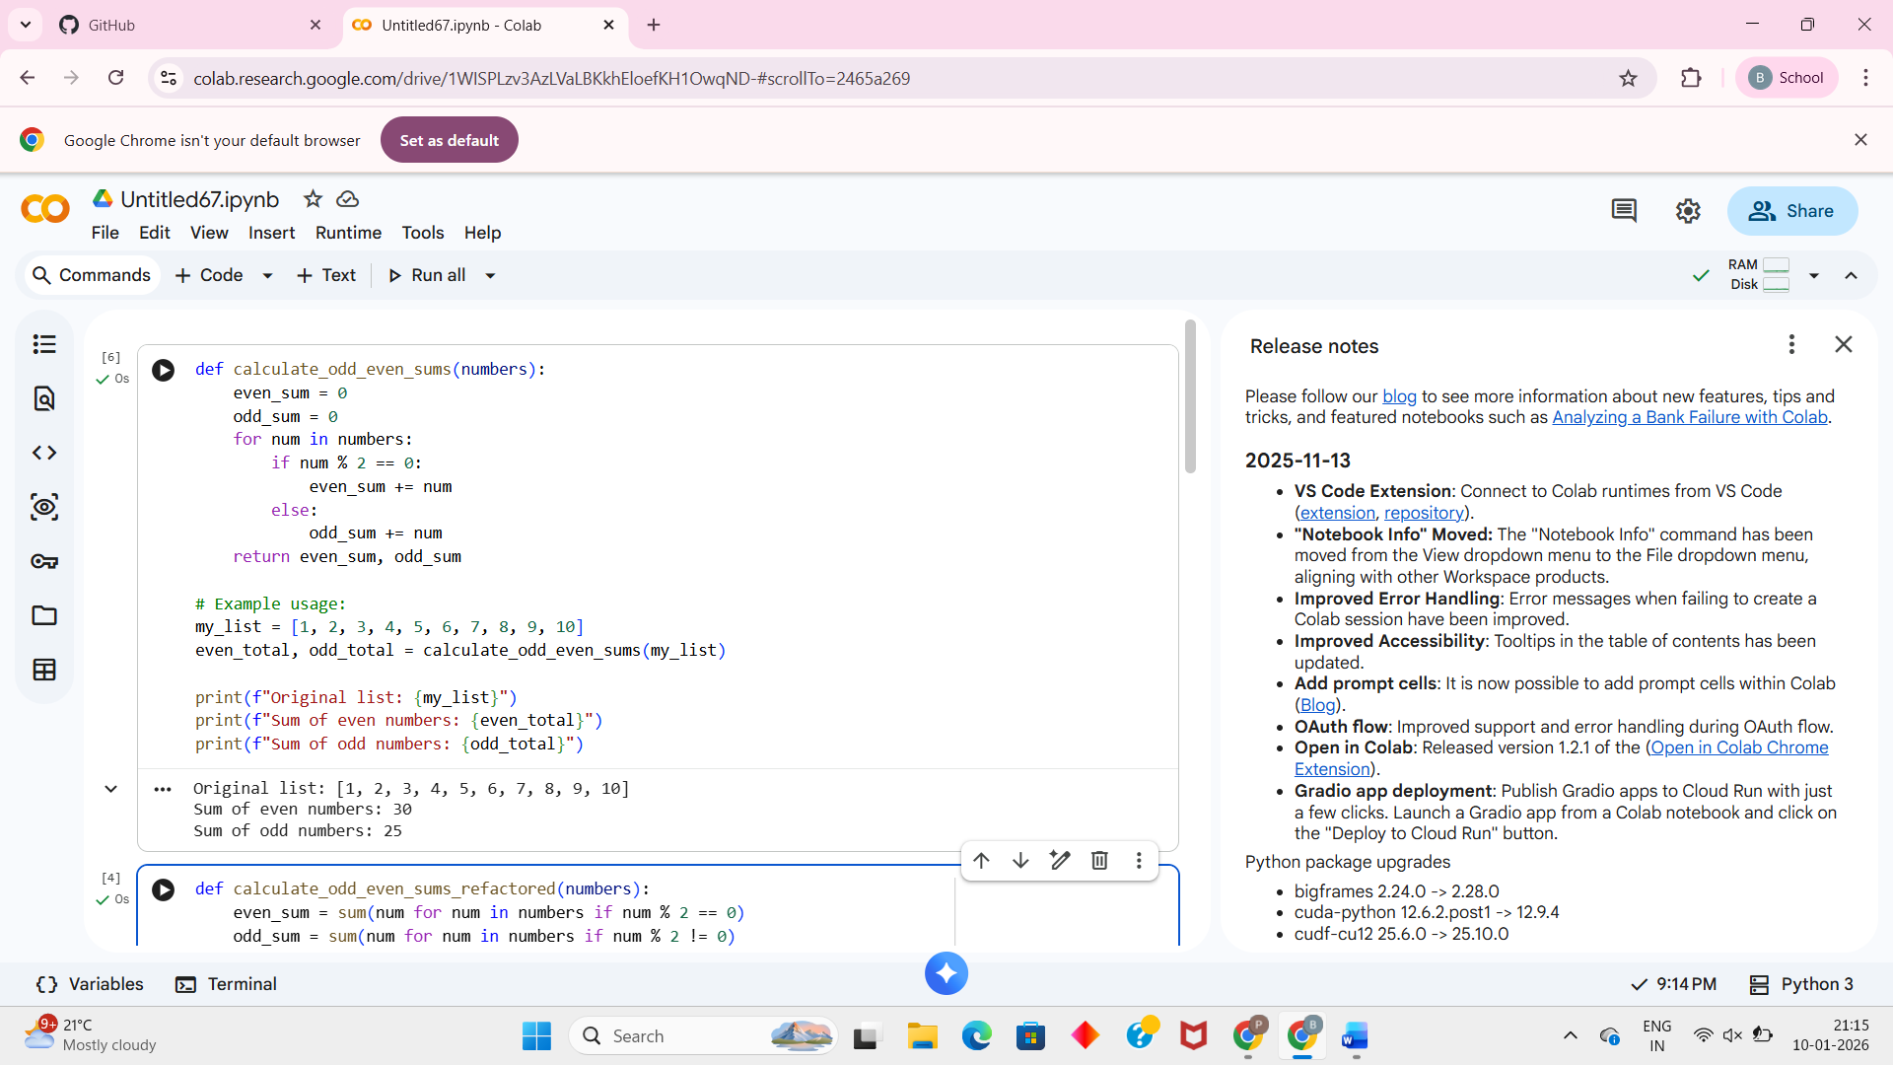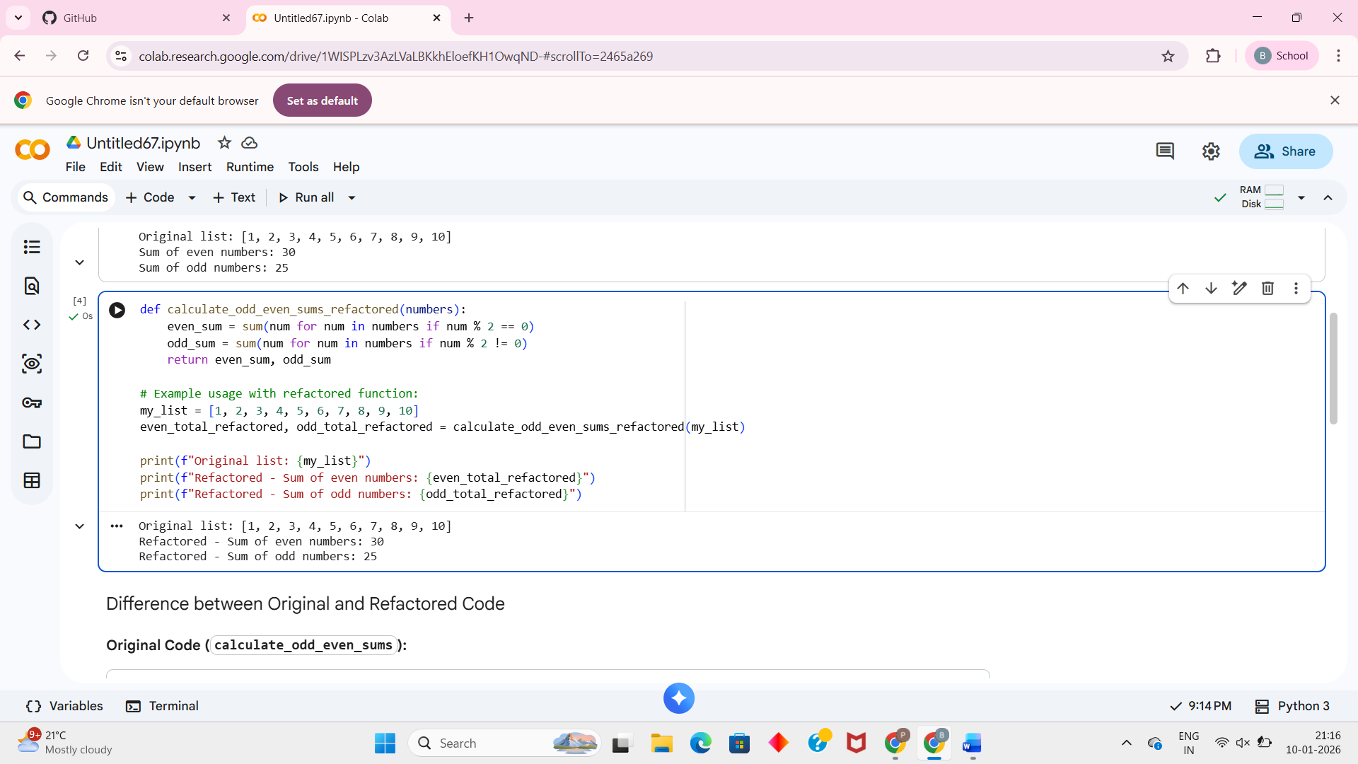
Explanation:
The refactored version improves readability by using Python’s built-in sum() function and list comprehensions. It reduces the number of lines and avoids manual looping, making the code cleaner and more efficient.

Task 2: Area Calculation Explanation Scenario
You are onboarding a junior developer and want a clear explanation of a function that calculates the area of different shapes.

Prompt Used (Google Gemini):
"Explain a Python function that calculates the area of different shapes like circle, rectangle, and triangle in simple terms."
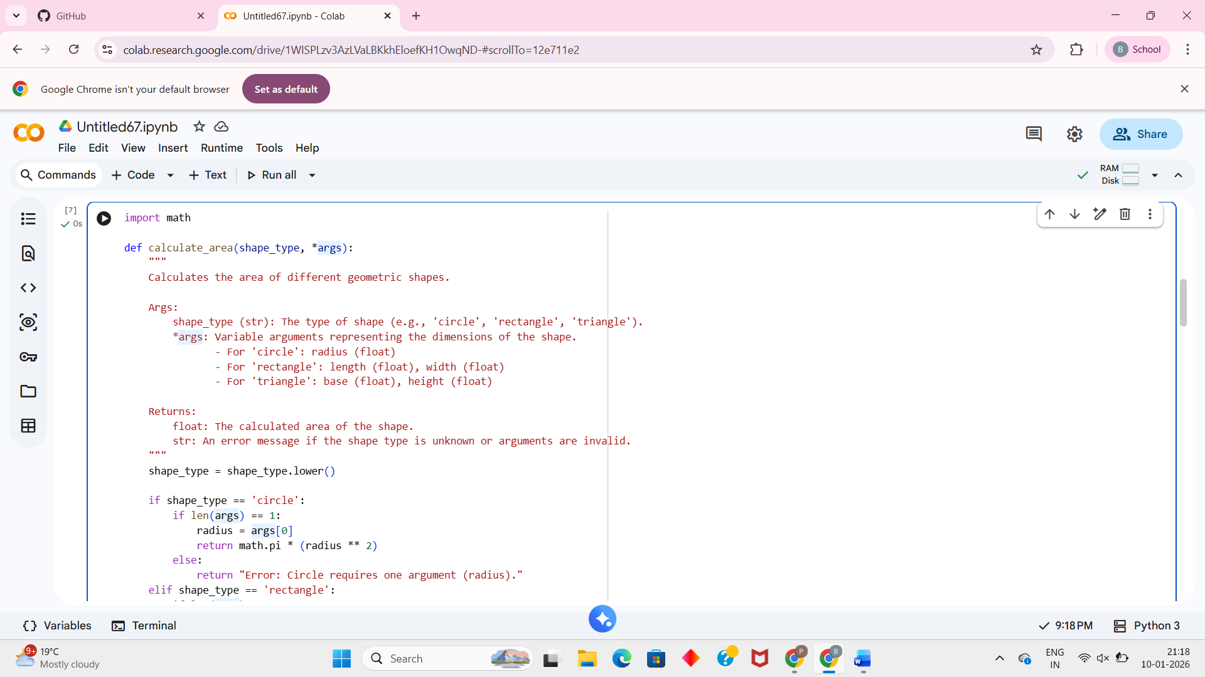
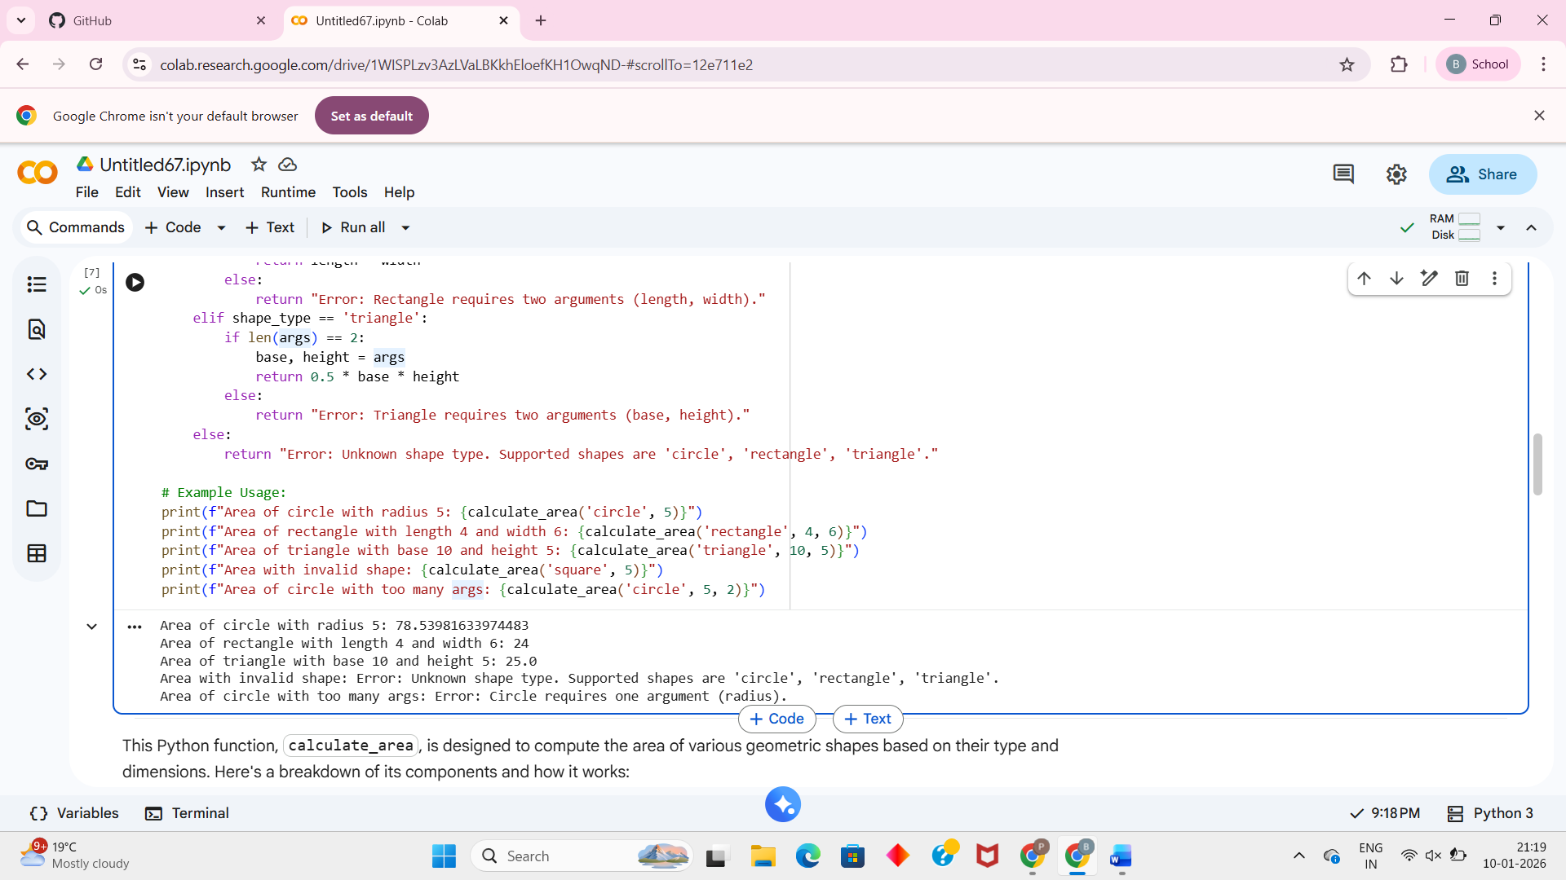

Code

import math

def calculate_area(shape_type, *args):
"""
Calculates the area of different geometric shapes.

Args:
shape_type (str): The type of shape (e.g., 'circle', 'rectangle', 'triangle').
*args: Variable arguments representing the dimensions of the shape.
- For 'circle': radius (float)
- For 'rectangle': length (float), width (float)
- For 'triangle': base (float), height (float)
Returns:
float: The calculated area of the shape.
str: An error message if the shape type is unknown or arguments are invalid.
"""
shape_type = shape_type.lower()

if shape_type == 'circle':
if len(args) == 1:
radius = args[0]
return math.pi * (radius ** 2)
else:
return "Error: Circle requires one argument (radius)."
elif shape_type == 'rectangle':
if len(args) == 2:
length, width = args
return length * width
else:
return "Error: Rectangle requires two arguments (length, width)."
elif shape_type == 'triangle':
if len(args) == 2:
base, height = args
return 0.5 * base * height
else:
return "Error: Triangle requires two arguments (base, height)."
else:
return "Error: Unknown shape type. Supported shapes are 'circle', 'rectangle', 'triangle'."

# Example Usage:
print(f"Area of circle with radius 5: {calculate_area('circle', 5)}")
print(f"Area of rectangle with length 4 and width 6: {calculate_area('rectangle', 4, 6)}")
print(f"Area of triangle with base 10 and height 5: {calculate_area('triangle', 10, 5)}")
print(f"Area with invalid shape: {calculate_area('square', 5)}")
print(f"Area of circle with too many args: {calculate_area('circle', 5, 2)}")

Task 3: Prompt Sensitivity Experiment Scenario
You are testing how Cursor AI responds to different prompts for the same problem.
Problem Statement
"Write a Python function to find the maximum number in a list."

Prompt 1
"Write a simple Python function to find the maximum element in a list."

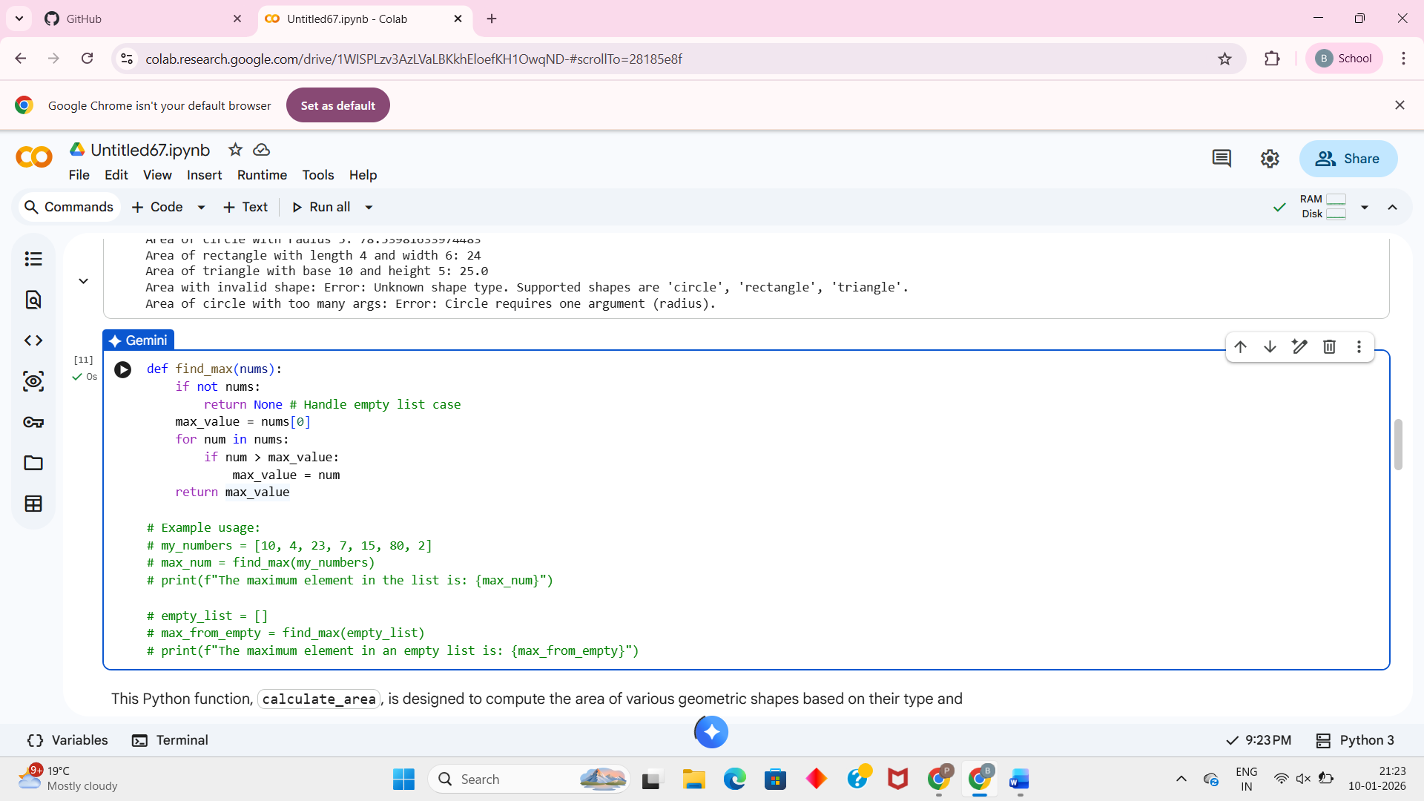
Prompt 2
"Write an optimized Python function to find the maximum number in a list using built-in functions."
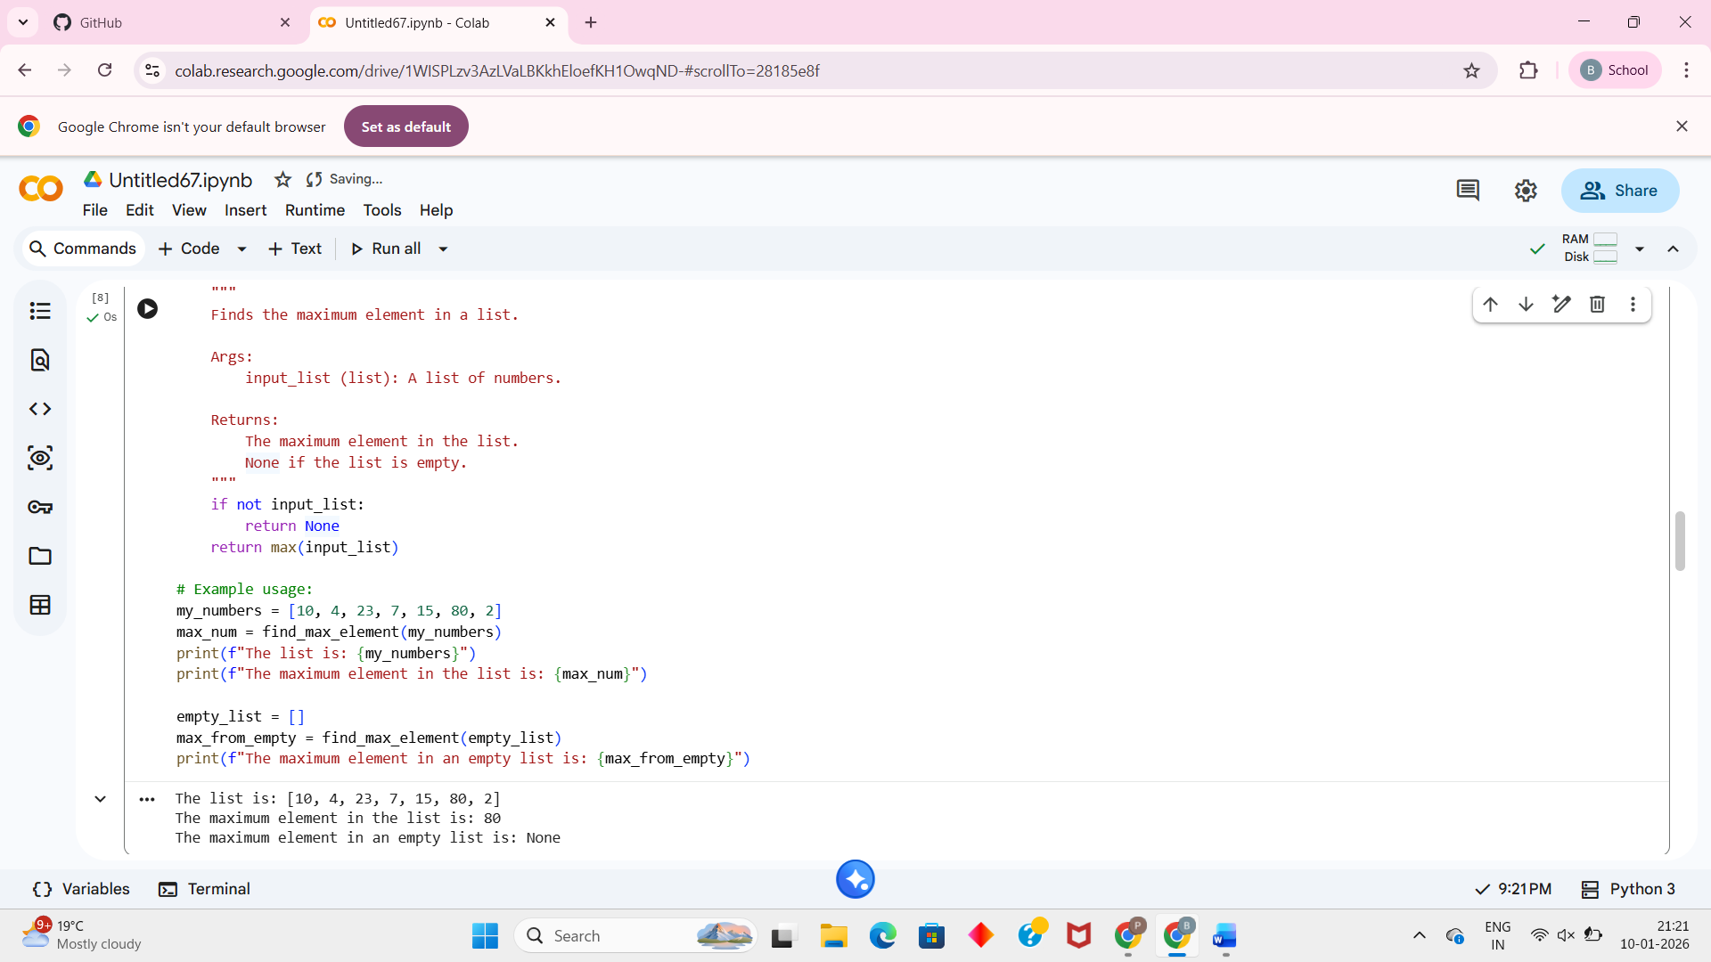

Output Code

Prompt 3
"Write a Python function with error handling to find the maximum number in a list."

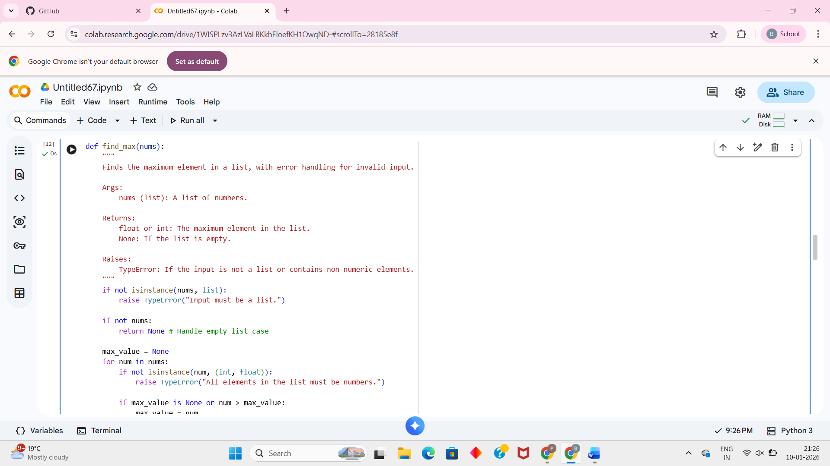
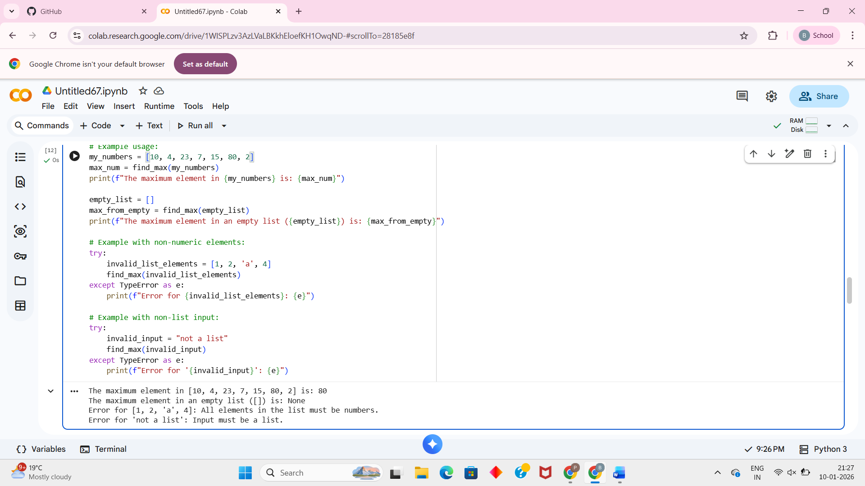
Output Code
def find_max(nums):
"""
Finds the maximum element in a list, with error handling for invalid input.

Args:
nums (list): A list of numbers.

Returns:
float or int: The maximum element in the list.
None: If the list is empty.

Raises:
TypeError: If the input is not a list or contains non-numeric elements.
"""
if not isinstance(nums, list):
raise TypeError("Input must be a list.")

if not nums:
return None # Handle empty list case

max_value = None
for num in nums:
if not isinstance(num, (int, float)):
raise TypeError("All elements in the list must be numbers.")

if max_value is None or num > max_value:
max_value = num

return max_value

# Example usage:
my_numbers = [10, 4, 23, 7, 15, 80, 2]
max_num = find_max(my_numbers)
print(f"The maximum element in {my_numbers} is: {max_num}")

empty_list = []
max_from_empty = find_max(empty_list)
print(f"The maximum element in an empty list ({empty_list}) is: {max_from_empty}")

# Example with non-numeric elements:
try:
invalid_list_elements = [1, 2, 'a', 4]
find_max(invalid_list_elements)
except TypeError as e:
print(f"Error for {invalid_list_elements}: {e}")

# Example with non-list input:
try:
invalid_input = "not a list"
find_max(invalid_input)
except TypeError as e:
print(f"Error for '{invalid_input}': {e}")

Observation
Cursor AI clearly demonstrates prompt sensitivity, meaning the quality, structure, and safety of the generated code change based on how the prompt is written.
- In Prompt 1, the instruction is very basic, so Cursor AI produces a traditional
loop-based solution. This version is easy to understand for beginners and shows the step-by-step logic of finding a maximum value manually.
- In Prompt 2, the word optimized guides Cursor AI to use Python’s built-in max() function. This results in shorter, cleaner, and more efficient code with better readability and performance.
- In Prompt 3, the phrase with error handling makes Cursor AI consider edge cases. The generated code checks whether the list is empty before applying max(), preventing runtime errors and improving reliability.

Task 4: Tool Comparison Reflection Reflection
Google Gemini is best for learning and understanding code because it explains
concepts clearly in simple language. It is very helpful for students and beginners who want to understand logic step by step. GitHub Copilot is useful for fast coding and
productivity, especially for experienced developers working on real projects. However, it focuses more on code completion than explanation. Cursor AI is strong in refactoring
and experimenting with different prompts, helping improve code quality, readability, and error handling. Each tool serves a different purpose based on learning, speed, or code improvement needs, making them suitable for different stages of software
development.

